Module 11: Managing Security and User Access
Database security ensures that only authorized users can access, modify, or view the data. SQL Server provides several features to secure your data and objects.

1️⃣ Granting and Revoking Permissions
SQL Server uses permissions to control access to objects such as tables, views, procedures, and schemas.
Common Permissions
Type | Examples
Database-level | CREATE TABLE, CREATE VIEW
Object-level | SELECT, INSERT, UPDATE, DELETE
Server-level | ALTER ANY LOGIN, CREATE DATABASE

1.1 GRANT Permission
Allows a user to access an object.
Example
-- Create a login at server level
CREATE LOGIN UserA WITH PASSWORD = '123';

-- Create a user inside the database
USE Infoys_Data;
CREATE USER UserA FOR LOGIN UserA;

-- Grant SELECT permissions on Employees table
GRANT SELECT ON [dbo].[Infosys_Company] TO UserA;

select * from [dbo].[Infosys_Company]

How to test?
EXECUTE AS USER = 'UserA';

SELECT * FROM [dbo].[Infosys_Company];

1.2 REVOKE Permission
Removes previously granted or denied permissions.
REVOKE SELECT ON [dbo].[Infosys_Company] FROM UserA;

1.3 DENY Permission
Explicitly prevents access — even if user has higher-level permissions.
DENY DELETE ON dbo.Employees TO UserA;

2️⃣ Securing Sensitive Data with Encryption & Hashing
Encryption protects data from unauthorized access. Hashing is used to store irreversible values (like passwords).

2.1 Column-Level Encryption
Steps
- Create a Master Key
- Create or open a Certificate
- Create a Symmetric Key
- Encrypt / Decrypt data using the key

🔐 Example: Encrypting Salary Column

Go to Database-----Infoys_Data
Go to Table-----------Infosys_Company
Go to columns under Infosys_Company Table
Go to Salary column and right click and choose Encrypt column
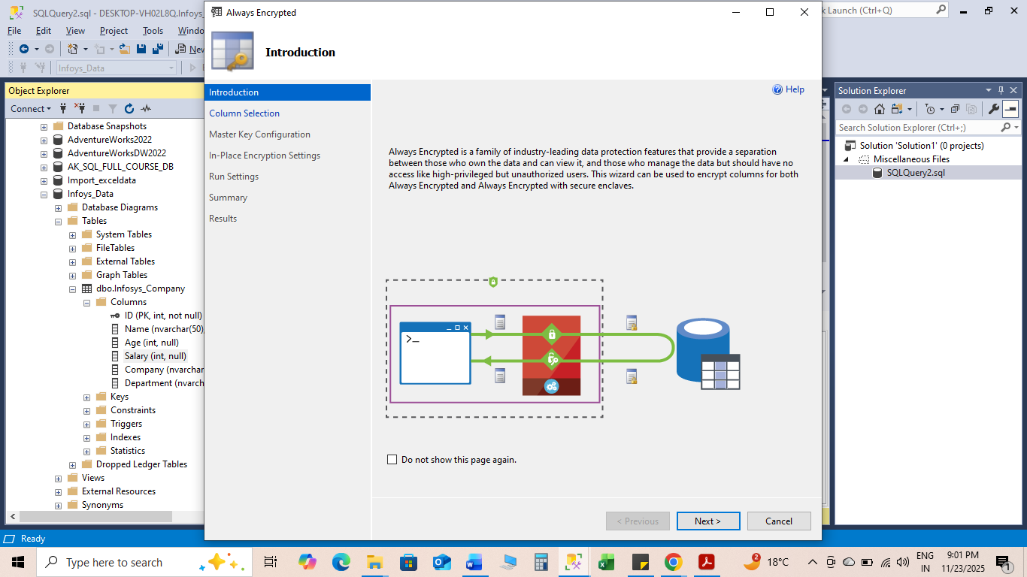
Click on NEXT
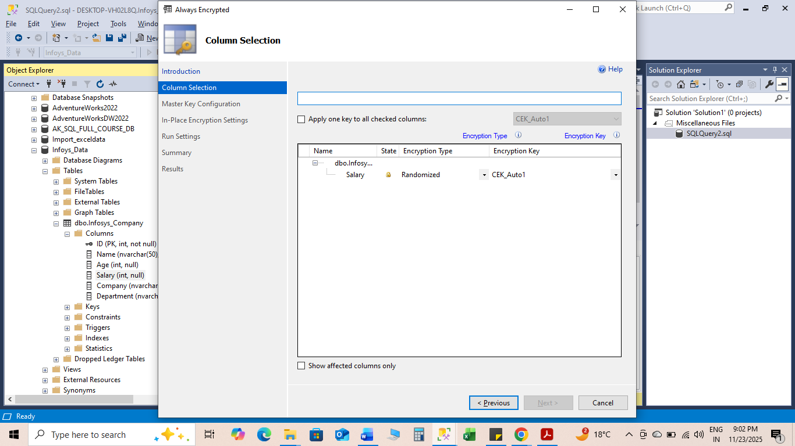
Choose Randomized
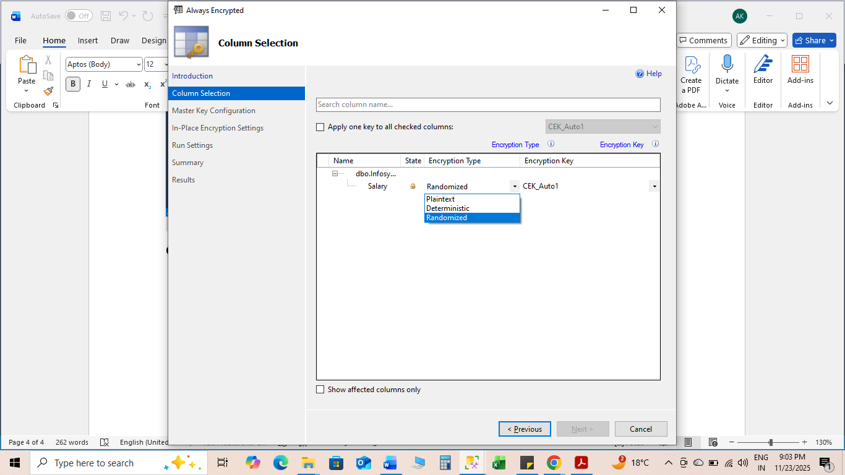
Click Next
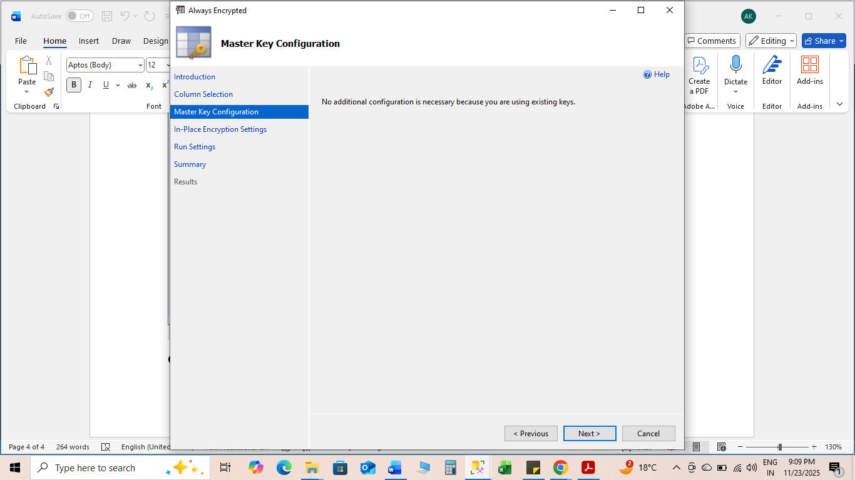
Click Next
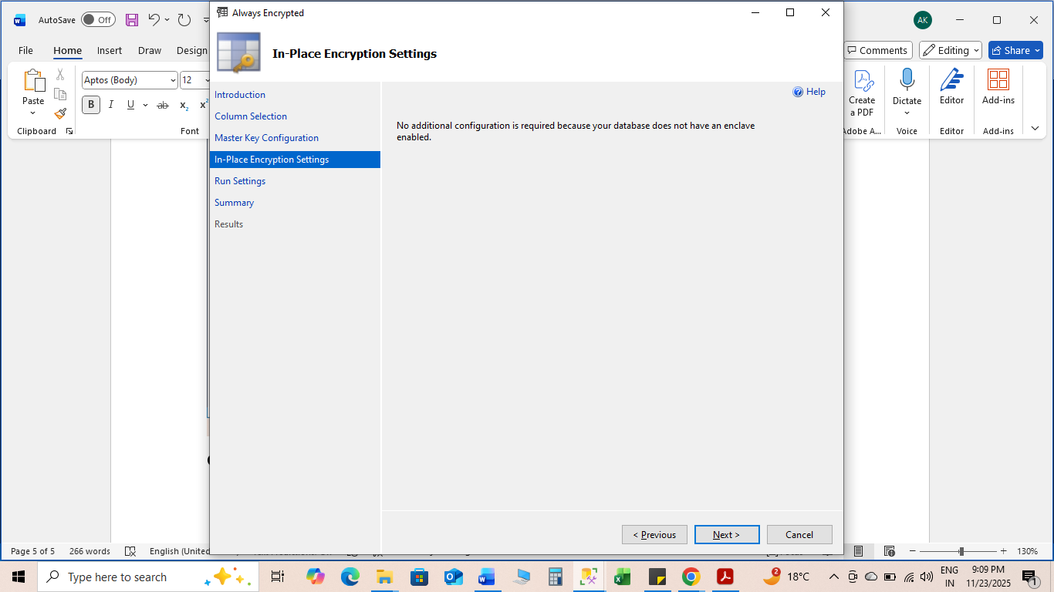
Click Next
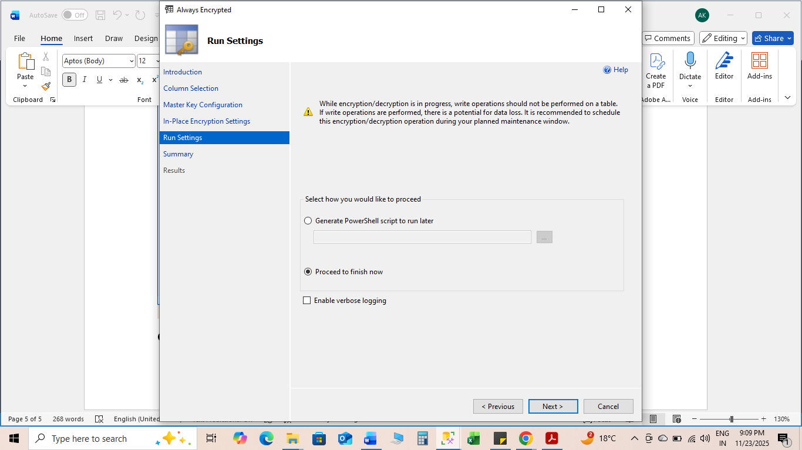
Click Next
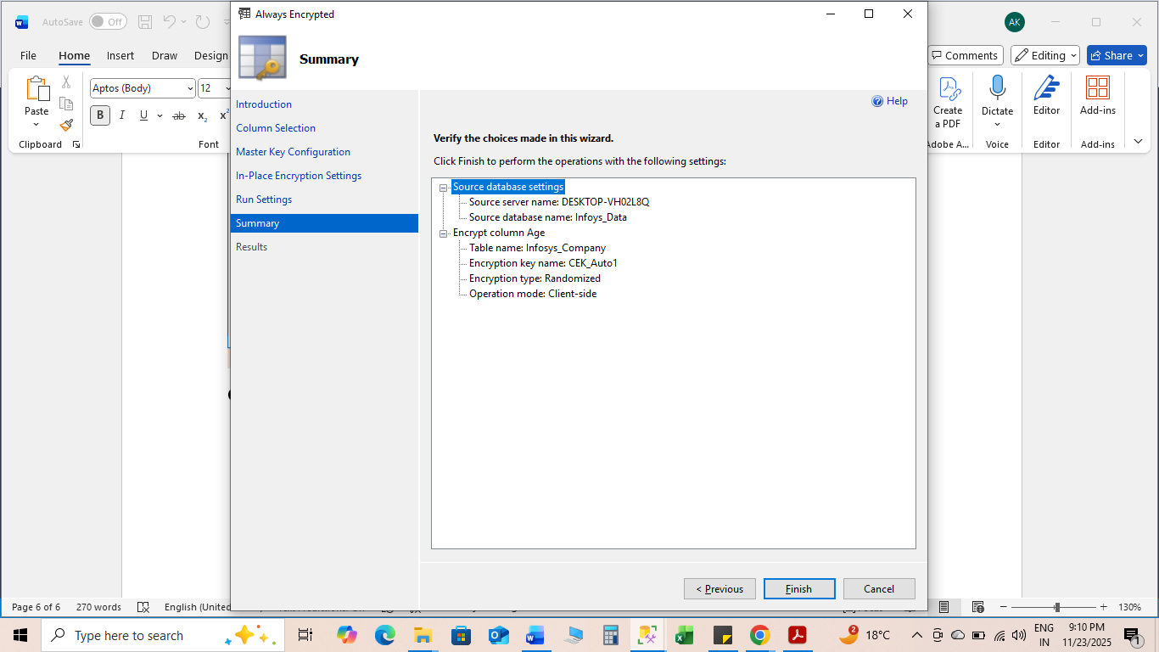
Click Finish
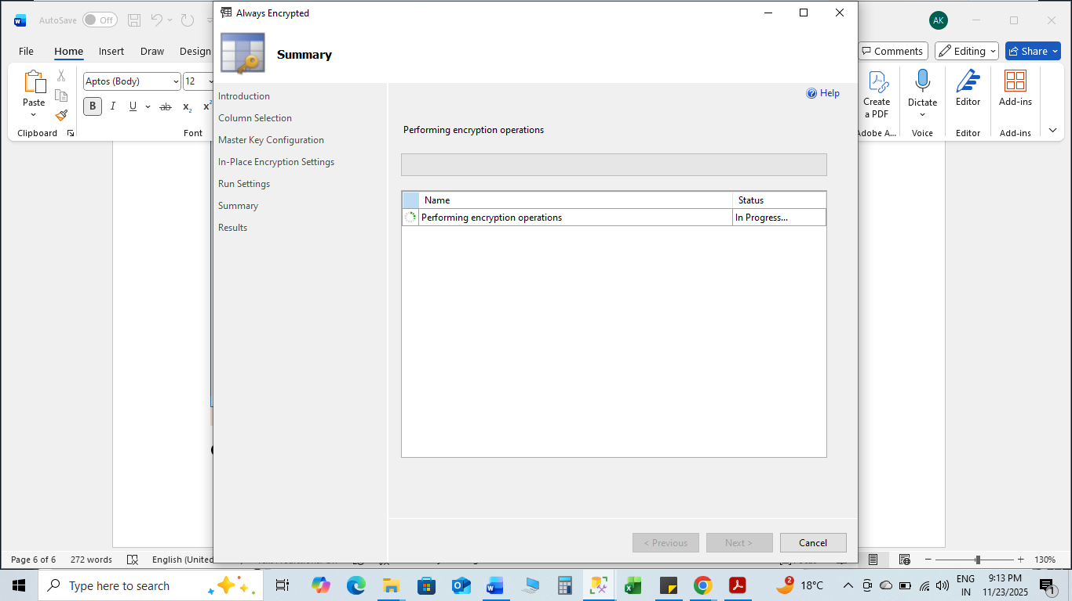
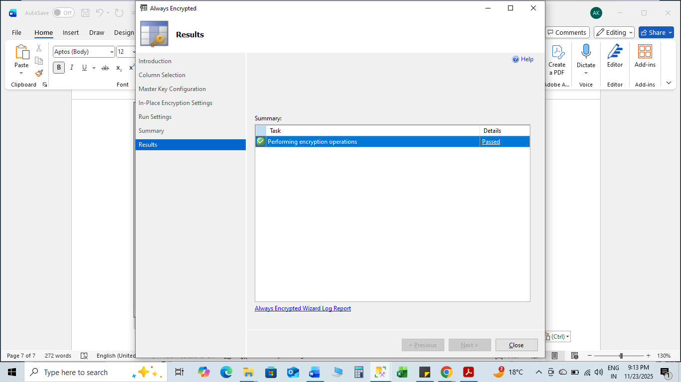
Click Close

Before Encryption
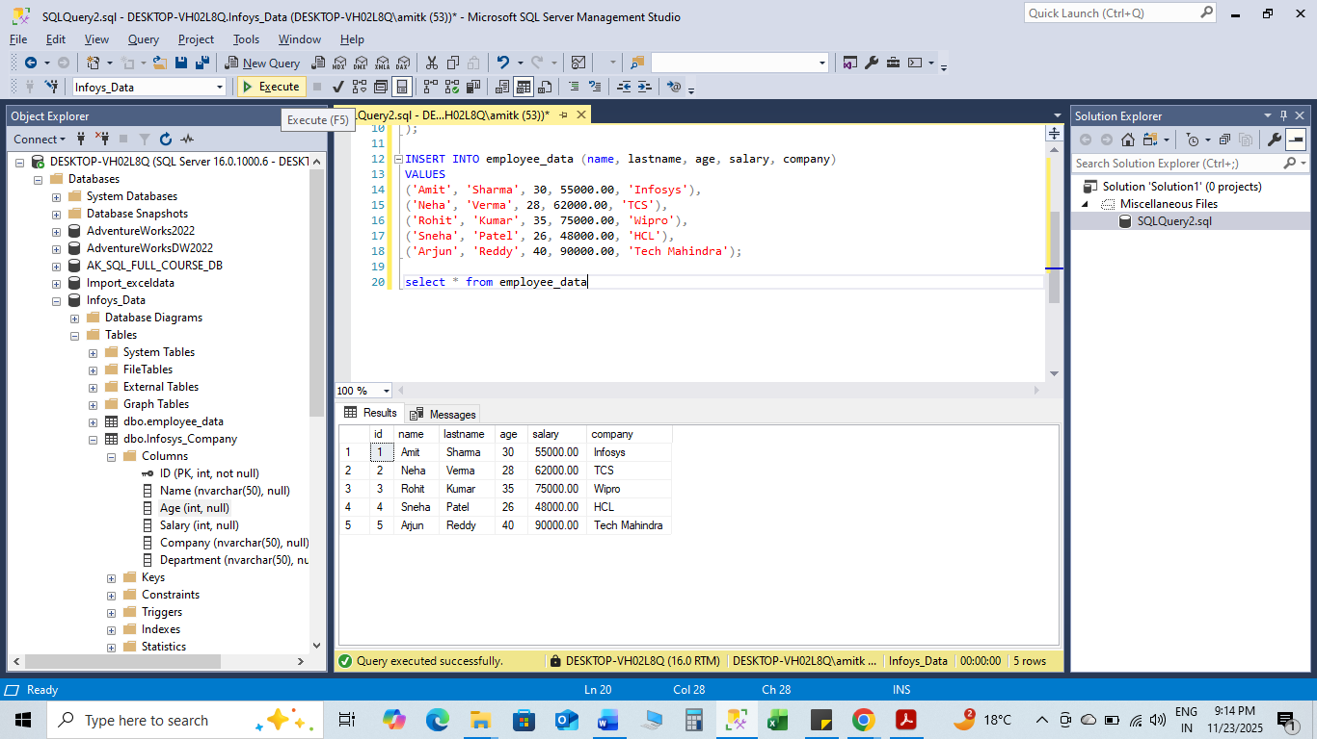

After Encryption
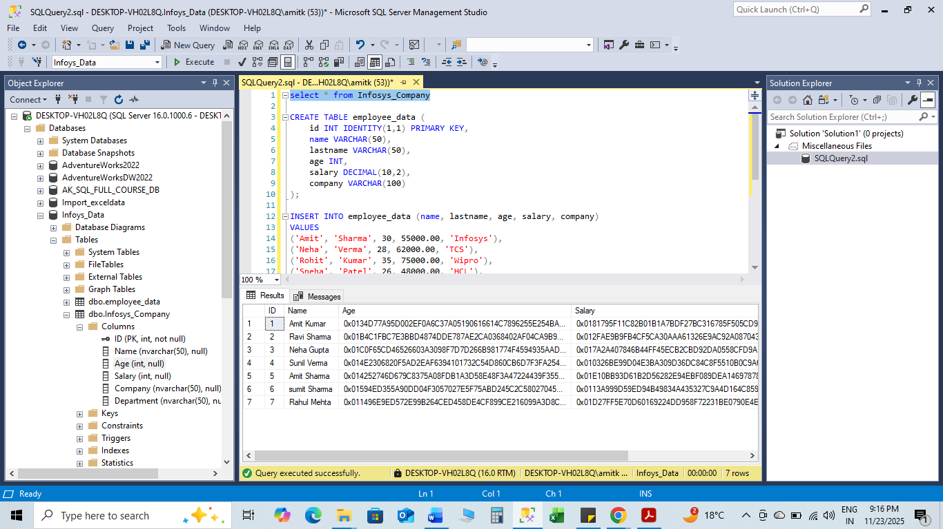

3️⃣ Implementing Row-Level Security (RLS)
RLS restricts data access based on the user, ensuring each user sees only their allowed rows.

Practical Example: Managers See Only Their Employees
Employees Table
EmpID | FullName | ManagerID
1 | John | M1
2 | Priya | M2
3 | Ahmed | M1

- Create Table and Sample Data
USE TCS_DATABASE;

CREATE TABLE dbo.Employees (
EmployeeID INT,
FirstName VARCHAR(50),
LastName VARCHAR(50),
Department VARCHAR(50),
Salary INT,
ManagerID VARCHAR(10) -- required for RLS
);

INSERT INTO dbo.Employees VALUES
(1, 'Amit', 'Sharma', 'IT', 55000, 'M1'),
(3, 'Rohit', 'Verma', 'Finance', 60000, 'M2'),
(4, 'Priya', 'Mehta', 'IT', 52000, 'M1'),
(6, 'Pooja', 'Rao', 'IT', 50000, 'M3'),
(9, 'Suresh', 'Patel', 'Finance', 61000, 'M2');

2. Create Security Schema
CREATE SCHEMA Security;

3. Create RLS Filter Function
This function allows a user to see only rows where ManagerID = USER_NAME()

CREATE FUNCTION Security.fn_FilterEmployees(@ManagerID AS VARCHAR(10))
RETURNS TABLE
WITH SCHEMABINDING
AS
RETURN
(
SELECT 1 AS AllowAccess
WHERE @ManagerID = USER_NAME()
);

- Create Row-Level Security Policy

CREATE SECURITY POLICY Security.EmployeeFilterPolicy
ADD FILTER PREDICATE Security.fn_FilterEmployees(ManagerID)
ON dbo.Employees
WITH (STATE = ON);

5. Create Users for Testing RLS
Example: Manager M1 only sees Amit and Priya

CREATE USER M1 WITHOUT LOGIN;
CREATE USER M2 WITHOUT LOGIN;
CREATE USER M3 WITHOUT LOGIN;

Grant select permission

GRANT SELECT ON dbo.Employees TO M1;
GRANT SELECT ON dbo.Employees TO M2;
GRANT SELECT ON dbo.Employees TO M3;

6. Test RLS
Test as M1

EXECUTE AS USER = 'M1';
SELECT * FROM dbo.Employees;
REVERT;

Expected Output for M1
EmployeeID | FirstName | LastName | Department | Salary
1 | Amit | Sharma | IT | 55000
4 | Priya | Mehta | IT | 52000

Test as M2
EXECUTE AS USER = 'M2';
SELECT * FROM dbo.Employees;
REVERT;

Expected Output:
- Rohit
- Suresh

Test as M3

EXECUTE AS USER = 'M3';
SELECT * FROM dbo.Employees;
REVERT;

Expected Output:
- Pooja

